Basics in Probability Theory

A random variable X is a function that assigns to each element s in the outcome space S one and only one real number, X(s)=x.

If P is a probability function and A and B are any sets is S, then
- P(Ø) = 0, where Ø is the empty set,
- 0<=P(A) <=1,
- P(A^{c})=1-P(A)
- If A₁, A₂,… A_{n}, belong to S and A_{i}A_{j} = Ø or each ij, then
$$P(\underset{i=1}{\overset{∞}{∪}}A_{i})=\sum_{i=1}^{∞}{P(A_{i})}$$
- If $A⊆B$then $P(A)≤P(B)$
- $$P(A∪B)=P(A)+P(B)−P(A∩B)$$

The probability density function (p.d.f.) of the random variable X with space S is an integrable function f(x) satisfying the following conditions:
- f(x) > 0, x є S,
- $\int_{S}{f(x)\text{dx}=1}$
- The probability of the event X є A is
$P(X∈A)=\int_{A}{f(x)\text{dx}}$ or
$$P(a≺X≺b)=\int_{a}^{b}{f(x)\text{dx}}$$
The cumulative distribution (c.d.f) of a random variable X defined in terms of the p.d.f. of X is given by
$F(x)=P(X≤x)=\int_{−∞}^{x}{f(t)\text{dt}}$
Here, F(x) cumulates all of the probability less than or equal to x.
The function F(x) is a c.d.f. if and only if the following three conditions hold:
a. ${\text{lim}}_{x→−∞}(F(x)=0,\text{.}\text{.}\text{.}{\text{,lim}}_{x→∞}F(x)=1$
- F(x) is a nondecreasing function of x
- F(x) is right continuous, that is, for every number x₀, ${\text{lim}}_{x↓x_{0}}F(x)=F(x_{0})$
Moments and Moment Generating Functions
The various moments of a distribution are an important class of expectations.
For each integer n, the nth moment of X, μ_{n}’, is
μ_{n}’=EX^{n}
the nth central moment of X, μ_{n}, is
μ_{n}=E(X-μ)^{n}
where μ= μ₁’,=EX
Aside from the mean, the most important moment is the variance.

The normal distribution
The normal distribution has two parameters, the mean μ and the variance σ². The pdf of the normal distribution with mean μ and variance σ², usually denoted by N(μ,σ²) is given by
$f(x)=\frac{1}{σ\sqrt{2π}}e^{−(x−μ{)^{2}}/2σ^{2}}$
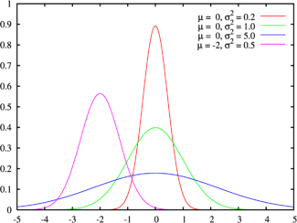
The green line is the standard normal distribution
Cumulative distribution function
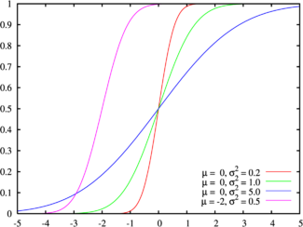
Colors match the image above
To indicate that a random varible X has the normal distribution, we right
The image to the right gives the graph of the probability density function of the normal distribution for various parameter values.
Some notable qualities of the normal distribution:
- The density function is symmetric about its mean value.
- 68.26894921371% of the area under the curve is within one standard deviation of the mean.
- 95.44997361036% of the area is within two standard deviations.
- 99.73002039367% of the area is within three standard deviations.

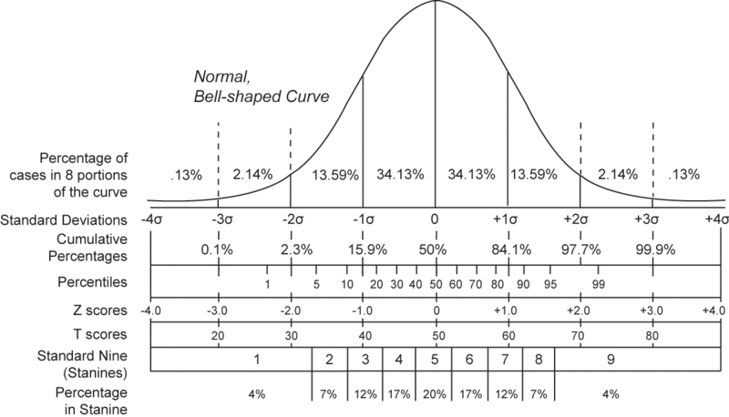

MATHEMATICAL OPTIMIZATION FOR THE PORTFOLIO PROBLEM.

Measuring Risk and Return

Measures of Location

The most often used measure of location is the mean or expectation. It is defined as
$$E(X)=\sum_{i=1}^{N}{p_{i}X_{i}}$$
where p_{i} is the probability of a random event, X_{i} and N is the total number of possible events.

Property 1: E(X+a)=E(X)+a, or
$$E(X+a)=\sum_{i=1}^{N}{p_{i}(X_{i}+a)}$$
Property 2: E(aX)=aE(X)
Another measure of location is the Median, which is the outcome in the middle, often referred to as the 50th percentile.
Last measure of location is the Mode, which is defined as the most frequent outcome.

Measures of Dispersion
The Range, is the simplest statistic and is defined as the difference between the highest and lowest outcome.
The Semiinterquartile range is the difference between the observation of the 75th percentile, X₇₅ and the 25th percentile X₂₅ divided by 2 : (X₇₅ – X₂₅ )/2
The variance is the statistic most frequently used to measure the dispersion of a distribution, and it is used as a measure of investment risk.
Variance = E[X-E(X)]²
The standard deviation, which is the positive square root of the variance, is often used to express dispersion:
σ(Χ)=[VAR(X)]^{1/2}
Property 3: VAR(X+a)=VAR(X)
Property 4: VAR(aX)=a²VAR(X)
One problem with the variance is that it gives equal weight to possibilities above as well as below the average.
The semivariance is a statistic that relates to just that risk. It is defined as the expectation of the mean differences below the mean, squared. Let
X_{i}= X_{i}-E(X), if X_{i} <E(X)
X_{i}=0 otherwise
Then, SEMIVAR=E[(X_{i})²]
Both the variance and the semivariance are sensitive to observations distant from the mean because the mean differences are squared. A statistic that avoids that is the Mean Absolute Deviation which is defined as the expectation of the absolute value of the differences from the mean:
MAD=E[|X_{i}-E(X)|]

Calculating the Mean and the Variance of a portfolio of two assets
If X and Y are two assets (random variables) which are not independent, then the portfolio return can be expressed as the weighted sum of two random variables:
R_{p}=aE(X)+bE(Y)
Where a and b are the weights of the wealth invested in asset X and Y respectively. The variance of the portfolio is expressed as
$$\begin{aligned}\text{VAR}(R_{p})=E[R_{p}−E(R_{p})]^{2}=E[(\text{aX}+\text{bY})−E(\text{aX}+\text{bY})]^{2}=E[(\text{aX}−\text{aE}(X))+(\text{bY}−\text{bE}(Y))]^{2}⇒ \\ \\ \\ \\ \end{aligned}$$
$$\begin{aligned}\text{VAR}(R_{p})=E[a^{2}(X−E(X))^{2}+b^{2}(Y−E(Y))^{2}+2\text{ab}(X−E(X))(Y−E(Y))] \\ \\ \\ \\ \end{aligned}$$
$$\begin{aligned}\text{VAR}(R_{p})=a^{2}E[(X−E(X))^{2}]+b^{2}E[(Y−E(Y))^{2}]+2\text{abE}[(X−E(X))(Y−E(Y))] \\ \\ \\ \\ \end{aligned}$$
The covariance of X and Y is the number defined by
Cov(X,Y)=E[(X- E(X)) (Υ-E(Y))]
Or Cov(X,Y)=E[XY]- E(X)E(Y)
Thus,
$$\begin{aligned}\text{VAR}(R_{p})=a^{2}\text{VAR}(X)+b^{2}\text{VAR}(Y)+2\text{abCov}(X,Y) \\ \\ \\ \\ \end{aligned}$$
Example :
Probability | X | Y
0.2  0.2  0.2  0.2  0.2 | 11%  9%  25%  7%  -2% | -3%  15%  2%  20%  6%

The expected value of X, E(X)=10%, while the expected value of Y, E(Y)=8%. The variances are:

VAR(X)=0.2(0.11-0.1)² + 0.2(0.09-0.1)² +0.2(0.25-0.1)² +0.2(0.07-0.1)² +0.2(-0.02-0.1)² =0.0076

VAR(Y)=0.2(-0.03-0.08)² + 0.2(0.15-0.8)²+0.2(0.02-0.08)²+0.2(0.2-0.8)²+0.2(-0.06-0.1)² =0.00708
The Covariance between X and Y is
Cov(X,Y)=E[(X-E(X))(Y-E(Y))]=
=0.2(0.11-0.1)(-0.03-0.08) + 0.2(0.09-0.1)(0.15-0.08) + 0.2(0.25-0.1) (0.02-
0.08)+ 0.2(0.07-0.1)(0.20-0.08)+ 0.2(-0.02-0.1)(0.06-0.08)=-0.0024
Negative covariance implies that the returns on assets X and Y tend to move in opposite direction. If we invest in both securities at once the result is a portfolio that is less risky than holding either asset separately. While we are losing with asset X, we win with asset Y. Therefore, our investment position is partially hedged, and risk is reduced. This is known as portfolio diversification.
As an illustration of the effect of diversification, suppose we invest half our assets in X and half in Y. We can use the above equations to compute directly the portfolio return and risk:
E(R_{p})=aE(X)+bE(Y)=0.5*0.1+0.5*0.08=9%
$\begin{aligned}\text{VAR}(R_{p})=a^{2}\text{VAR}(X)+b^{2}\text{VAR}(Y)+2\text{abCov}(X,Y) \\ \\ \\ \\ \end{aligned}$
=(0.5)²(0.0076) + (0.5)²(0.00708)+2(0.5)(0.5)(-0.0024)
=0.00247, or σ(R_{p})=4.97%
The advantage of portfolio diversification becomes clear in this example. With half our assets in X and half in Y, the expected return is halfway between that offered by assets X and Y, but the portfolio risk is considerably less than either VAR(X) or VAR(Y).

The correlation of X and Y is the number defined as the covariance divided by the product of the standard deviations:
r_{XY}=Cov(X,Y)/ σ_{Χ} σ_{Υ}
This in turn can be substituted into the definition of the variance of a portfolio of two assets:
$$\begin{aligned}\text{VAR}(R_{p})=a^{2}\text{VAR}(X)+b^{2}\text{VAR}(Y)+2{\text{abr}}_{\text{XY}}σ_{X}σ_{Y} \\ \\ \\ \\ \end{aligned}$$
The correlation coefficient varies between –1 and 1. The correlation coefficient of two assets X and Y is equal to –1, if these assets are exactly opposite. The correlation coefficient is equal to 0 if the two assets are independent. Finally, the correlation coefficient is equal to 1 if one asset is a linear function of the other. In other words, if we are given the value of X, we know for sure what the corresponding value of Y will be:

Y=a +bX

The Minimum Variance Portfolio
The last formulation of the variance definition is what we will use from now on. Recall that since the sum of weights must add to 1, b=1-a. Therefore, the variance can be rewritten:
VAR(R_{p})=a²σ²_{X} + (1-a)²σ²_{Y} + 2a(1-a) r_{XY} σ_{X} σ_{Y}
We can minimize portfolio variance by setting the first derivative equal to zero:
$$\frac{\text{dVAR}(R_{p})}{\text{da}}=2{aσ}_{X}^{2}−2σ_{Y}^{2}+2{aσ}_{Y}^{2}+2r_{\text{XY}}σ_{X}σ_{Y}−4{\text{ar}}_{\text{XY}}σ_{X}σ_{Y}=0$$
a(σ²_{X} + σ²_{Y} - 2r_{XY} σ_{X} σ_{Y}) + r_{XY} σ_{X} σ_{Y} - σ²_{Y} =0
Solving for the optimal portfolio percentage to invest in X in order to obtain the minimum variance portfolio, we get
$a^{}=\frac{σ_{Y}^{2}−r_{\text{XY}}σ_{X}σ_{Y}}{σ_{X}^{2}+σ_{Y}^{2}−2r_{\text{XY}}σ_{X}σ_{Y}}$
Continuing with the previous example, we see that the minimum variance portfolio is the one where
$a^{}=\frac{0\text{.}\text{00708}−(−0\text{.}\text{33})(0\text{.}\text{0872})(0\text{.}\text{0841})}{0\text{.}\text{0076}+0\text{.}\text{00708}−2(−0\text{.}\text{33})(0\text{.}\text{0872})(0\text{.}\text{0841})}=0\text{.}\text{487}$
The portfolio return and variance for the minimum risk portfolio are:
E(R_{p})=aE(X)+(1-a)E(Y)=0.487(0.1) + 0.513(0.08) = 8.974%
VAR(R_{p}) = a²σ²_{X} + (1-a)²σ²_{Y} + 2a(1-a) r_{XY} σ_{X} σ_{Y}=
= (0.487)²(0.0076)+ (0.514)²(0.00708)+2(0.487)(0.513)(-0.33)(0.0872)(0.0841)
= 0.0024565
σ_{p}=4.956%

Return R_{p}

10% A

r_{XY} =-1
C r_{XY}=-0.33 r_{XY} =1

8% B
standard deviation σ_{p}
Risk/Return trade-offs for two assets

Perfectly correlated assets

What happens if assets X and Y are perfectly correlated? Say for example, that
X=1.037Y + 1.703. All combinations of X and Y lie along a straight line and hence are perfectly correlated. To show that, we will find the slope of the line, and prove that it is not change with a, the proportion invested in X.
We take a look at the definitions of mean and variance when r_{XY} =1.
E(R_{p})=aE(X)+(1-a)E(Y)
VAR(R_{p}) = a²σ²_{X} + (1-a)²σ²_{Y} + 2a(1-a) σ_{X} σ_{Y}= [a σ_{X} + (1-a)σ_{Y} ]²
σ(R_{p})= a σ_{X} + (1-a)σ_{Y}
Then, the slope of the line is
Slope = dE(R_{p})/ dσ(R_{p}) = $\frac{\text{dE}(R_{p})/{\text{da}}}{dσ(R_{p})/{\text{da}}}=\frac{E(X)−E(Y)}{σ_{X}−σ_{Y}}$
Therefore, in our case the slope is 6.45. This proves that AB is a straight line since no matter what percentage of wealth a we choose to invest in X, the trade-off between expected return and standard deviation is constant.

Perfectly inversely correlated assets
Finally, suppose that returns on X and Y are perfectly inversely correlated, so r_{XY} =-1. We would expect that in this case it would be possible to construct a perfect hedge. That is, the appropriate choice of a will result in a portfolio with zero variance. The mean and the variance of the portfolio with two perfectly inversely correlated assets are:
E(R_{p})=aE(X)+(1-a)E(Y)
VAR(R_{p}) = a²σ²_{X} + (1-a)²σ²_{Y} - 2a(1-a) σ_{X} σ_{Y}= [a σ_{X} - (1-a)σ_{Y} ]²
σ(R_{p})= +-[a σ_{X} + (1-a)σ_{Y}]
Note that σ(R_{p}) has both a positive and a negative root. The dotted line in the above graph is really two line segments, one with a positive slope and the other one with a negative slope.
The minimum variance portfolio is
$a^{}=\frac{σ_{Y}^{2}−r_{\text{XY}}σ_{X}σ_{Y}}{σ_{X}^{2}+σ_{Y}^{2}−2r_{\text{XY}}σ_{X}σ_{Y}}=\frac{σ_{Y}}{σ_{X}+σ_{Y}}=\text{49}\text{.}\text{095}\text{\%}$
and
E(R_{p})=0.49095(0.1) + (1-0.49095)(0.08)=8.982%
σ(R_{p})= 0.49095(0.0872) + (1-0.49095)(0.0841)=0

Since standard deviations cannot be negative, the two roots need to be interpreted as follows: As long as a>49.095%, the standard deviation of the portfolio is:
σ(R_{p})= a σ_{X} - (1-a)σ_{Y}, if a > σ_{Y} /(σ_{X} +σ_{Y})
On the other hand, if less than 49.095% is invested in asset X, then the portfolio standard deviation is
σ(R_{p})= - a σ_{X} + (1-a)σ_{Y}, if a < σ_{Y} /(σ_{X} +σ_{Y})
We use these results to show that the line segments AC and CB are linear.
For the positively sloped line segment AC we have
dE(R_{p})/ ad = E(X) – E(Y)
dσ(R_{p})/ da= σ_{X} + σ_{Y,} if a > σ_{Y} /(σ_{X} +σ_{Y}), and
dE(R_{p})/ dσ(R_{p}) = $\frac{\text{dE}(R_{p})/{\text{da}}}{dσ(R_{p})/{\text{da}}}=\frac{E(X)−E(Y)}{σ_{X}+σ_{Y}}$=0.117
The slope of AC is positive and AC is linear because the slope is invariant to changes in the percentage of an investor’s portfolio invested in X.
For the negative sloped line segment, CB, we have:
dE(R_{p})/ ad = E(X) – E(Y)
dσ(R_{p})/ da= - σ_{X} - σ_{Y,} if a < σ_{Y} /(σ_{X} +σ_{Y}), and
dE(R_{p})/ dσ(R_{p}) = $\frac{\text{dE}(R_{p})/{\text{da}}}{dσ(R_{p})/{\text{da}}}=\frac{E(X)−E(Y)}{−(σ_{X}+σ_{Y})}$=-0.117
Thus, the slope of CB is negative, and CB is linear.

The Efficiency Set with one risky and one riskless asset
If one of the two assets, R_{f}, has zero variance, then the mean and variance of the portfolio become:
E(R_{p})=aE(X)+(1-a) R_{f},
VAR(R_{p}) = a²VAR(X)
We assume that the risk-free rate is R_{f}. Its variance and its covariance with the risky asset are zero. The opportunity set is a straight line. To prove this, we will compute again the slope and we will show that it is independent of a. The change in expected return with respect to the percentage invested in X is:
dE(R_{p})/ da = E(X) - R_{f},
and the change in standard deviation with respect to a is:
dσ(R_{p})/ da= σ_{X,}

Then, the slope of the line is
$\frac{\text{dE}(R_{p})/{\text{da}}}{dσ(R_{p})/{\text{da}}}=\frac{E(X)−R_{f}}{σ_{X}}$, constant.

Return R_{p}

X a>1 V
E(X) Borrowing
0<a<1
Y lending
R_{f}
a<0
lending and
short selling Z
σ_{X}
Opportunity Set with one risky and one riskless asset
It is assumed that the borrowing and lending rate in the economy are equal with the riskless rate. Thus, YXV is a straight line. To reach portfolios along the line segment XV it is necessary to borrow in order to invest more than 100% of the portfolio in the risky asset. Therefore, along that segment line, the percentage invested in X is greater than 1, a>1. The mean and the standard deviation of the portfolio are:
E(R_{p})=aE(X)+(1-a) R_{f},
σ(R_{p}) = a σ_{X}.
On the other hand, when we decide to invest more than 100% in the riskless asset, we must sell short the risky asset. The mean and the variance of the portfolio then are
E(R_{p})=aE(X)+(1-a) R_{f},
σ(R_{p}) = |a| σ_{X}.
Note that, because negative standard deviations are impossible, the absolute value of a is used to measure the standard deviation of the portfolio when the risky asset is sold short.
Clearly, no-risk averse investor would ever prefer line segment YZ, since he can do better along the positively sloped line segment YXZ. Therefore, the efficient set is composed of long positions in the risky asset combined with borrowing or lending.

Exercise
- calculate the mean and the variance, and the covariance term
- calculate the mean and the variance of the following portfolios: x: 125 100 75 50 25 0 -25
y: -25 0 25 50 75 100 125
- find the portfolio that has the minimum variance
- Let portfolio A has 75% in X and portfolio have 25% in X. Calculate the covariance between the two portfolios

(a)
p_{i} | X_{i} | p_{i}X_{i} | X_{i} – E(X) | [X_{i} – E(X)]² | p_{i}[X_{i} – E(X)]² | Y_{i} | p_{i}Y_{i}
.2 | 18 | 3.6 | 9.0 | 81.00 | 16.2 | 0 | 0
.2 | 5 | 1.0 | –4.0 | 16.00 | 3.2 | –3 | –.6
.2 | 12 | 2.4 | 3.0 | 9.00 | 1.8 | 15 | 3.0
.2 | 4 | .8 | –5.0 | 25.00 | 5.0 | 12 | 2.4
.2 | 6 | 1.2 | –3.0 | 9.00 | 1.8 | 1 | .2
 |  | E(X) = 9.0 |  |  | var(X) = 28.0 |  | E(Y) = 5.0

Y_{i} – E(Y) | [Y_{i} – E(Y)]² | p_{i}[Y_{i} – E(Y)]² | p_{i}[X_{i} – E(X)][Y_{i} – E(Y)]
–5 | 25 | 5.0 | –9.0
–8 | 64 | 12.8 | 6.4
10 | 100 | 20.0 | 6.0
7 | 49 | 9.8 | –7.0
–4 | 16 | 3.2 | 2.4
 |  | var(Y) = 50.8 | cov(X, Y) = –1.2
(b) Mean = aE(X) + (1 – a)E(Y)
Variance =
% in X | % in Y | E(R_{p}) | var(R_{p}) | σ_{p}
125 | –25 | 10.0 | 47.675 | 6.905
100 | 0 | 9.0 | 28.000 | 5.292
75 | 25 | 8.0 | 18.475 | 4.298
50 | 50 | 7.0 | 19.100 | 4.370
25 | 75 | 6.0 | 29.875 | 5.466
0 | 100 | 5.0 | 50.800 | 7.127
–25 | 125 | 4.0 | 81.875 | 9.048
The opportunity set is shown in Figure on the following page.
(c) The minimum variance portfolio is given by equation 5.21.
Recognizing the relationship between r_{xy} and cov(x, y),
cov(x, y) = r_{xy}σ_{x}σ_{y}
and substituting cov(x, y) into equation 5.21,

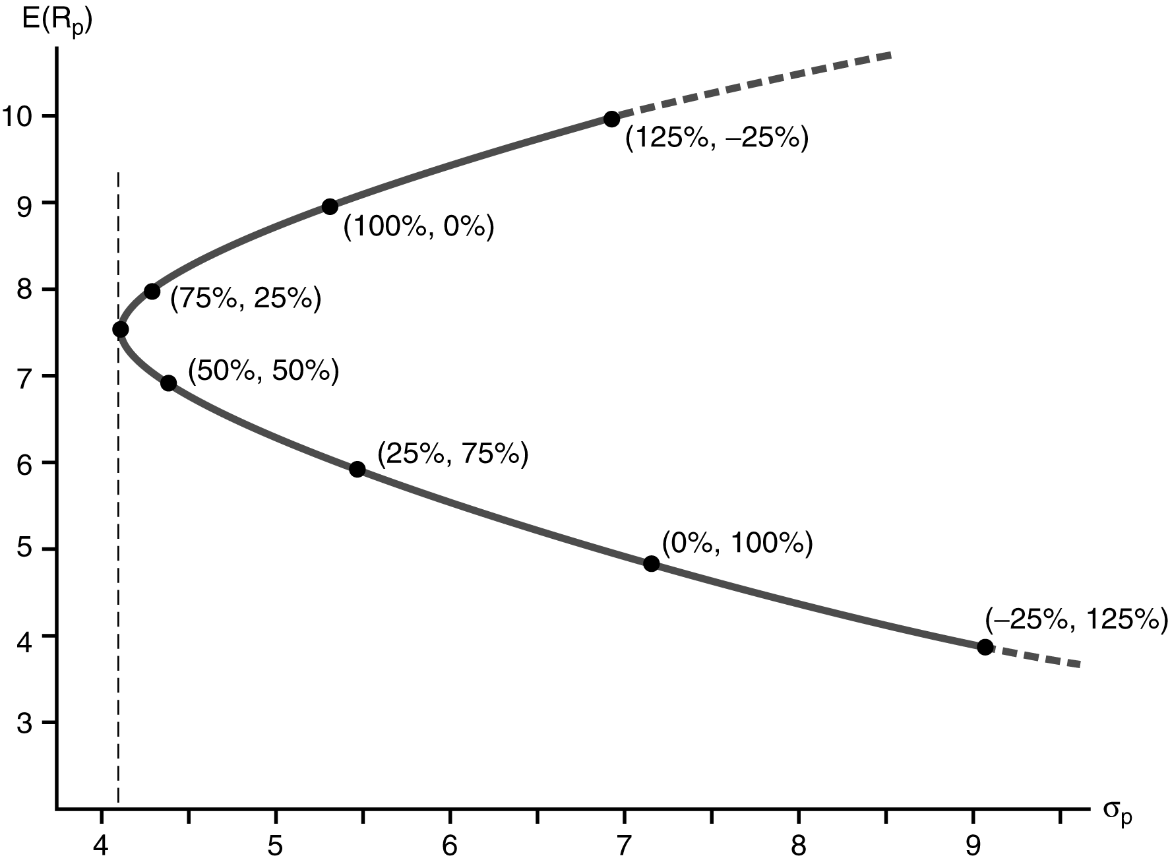

Figure. The opportunity set
Thus, the minimum variance portfolio has 64 percent invested in asset x and 36 percent in asset y.
The portfolio mean and variance at this point are:
(d) Portfolio A is 75 percent in X and 25 percent in Y; portfolio B is 25 percent in X and 75 percent in Y. The covariance between the two is

Optimal Portfolio Choice : Many Assets
We want to minimize risk -- the standard deviation or the variance of the portfolio -- given certain technical and other constraints for a given level of return. Alternatively we want to maximize the portfolio return given constraints and given the portfolio volatility. We seek the optimal portfolio as defined by the weights of the securities in it. The volatility of the portfolio is a highly non-linear function of the weights, whereas most of the other constraints are linear. Also the portfolio return is linear in the weights. Knowledge of the mathematics of optimization hints the selection of the problem formulation. We prefer to minimize the risk given the return and other linear constraints, instead of maximizing return given non-linear constraints (for the level of risk). This choice we make because it is easier to minimize a non-linear function with linear constraints than the other alternative. Also note the one-to-one relation between the standard deviation and the variance of assets. Instead of minimizing the standard deviation we can minimize the variance and we get the same results for the portfolio allocation. The variance is a quadratic function in the weights, and several convenient mathematical methods exist for optimization of such a function. The one we will show here is called the method of the Langrangean multipliers. It allows the solution of the general portfolio problem with short sales. The main requirement is that the constraints must be in equality form.

We will exhibit the method for the case of three risky assets without a risk free rate. It easily generalizable to N-assets, with or without the risk free rate. The inclusion of the risk free rate is easy, by treating the risk free rate as a risky asset with zero volatility and zero correlation with all the other assets. The problem formulation follows.

Minimize risk (the portfolio variance): w²_{A}σ²_{A} + w²_{B}σ²_{B} + w²_{C}σ²_{C} + 2w_{A}w_{B}σ_{A}σ_{B}r_{A,B}
+ 2w_{A}w_{C}σ_{A}σ_{C}r_{A,C} + 2w_{B}w_{C}σ_{B}σ_{C} r_{B,C}

or if we replace the products σ_{A}σ_{C}r_{A,C} with the covariance σ_{A,C} etc.
we minimize the: w²_{A}σ²_{A} + w²_{B}σ²_{B} + w²_{C}σ²_{C} + 2w_{A}w_{B}σ_{A,B} + 2w_{A}w_{C}σ_{A,C} + 2w_{B}w_{C}σ_{B,C}

This minimization is subject to constraints:

A. The sum of weights equals one: w_{A} + w_{B} + w_{C} = 1
B. The desired return level is R (given): w_{A}R_{A} + w_{B}R_{B} + w_{C}R_{C} = R

Note that if we do not use the second constraint and in the absence of a risk free rate we will get the minimum variance portfolio. It is actually advisable to first get the minimum variance portfolio before we proceed in a real problem. Then, by changing the level of desired return, we trace points on the efficient frontier.

Then we make two simplifications to the problem. First, we replace everywhere w_{C} with (1 - w_{A} - w_{B}). Second, we rearrange the constraint w_{A}R_{A} + w_{B}R_{B} + w_{C}R_{C} = R as R - w_{A}R_{A} - w_{B}R_{B} - w_{C}R_{C} = 0 and since it equals zero, we multiply it with a constant λ, and we get λ(R - w_{A}R_{A} - w_{B}R_{B} - w_{C}R_{C}) = 0. Since this equals zero, we add it to the objective function that we want to minimize without affecting the results. Finally we minimize the quadratic function without any constraints. Thus, we minimize a function (call it f):

f = w²_{A}σ²_{A} + w²_{B}σ²_{B} + (1 - w_{A} - w_{B})²σ²_{C} + 2w_{A}w_{B}σ_{A,B} + 2w_{A}(1 - w_{A} - w_{B})σ_{A,C}
+ 2w_{B}(1 - w_{A} - w_{B})σ_{B,C} + λ(R - w_{A}R_{A} - w_{B}R_{B} - (1 - w_{A} - w_{B})R_{C})

We need to solve this problem to find the weights of the three assets in the portfolio. We thus first find the solution to the w_{A}, w_{B}, and λ. The way to solve the above problem is now easy. We take the partial derivatives each time in respect to one of the three unknowns and set them equal to zero, and we will derive a set of three equations with three unknowns. The first is the partial derivative of f in respect to w_{A} , the second in respect to w_{B}, and the third in respect to the Langrangean multiplier λ.

The first equation gives
2w_{A}σ²_{A} + (2w_{A} + 2w_{B} -2)σ²_{C} + 2w_{B}σ_{A,B} + (2 - 4w_{A} - 2w_{B})σ_{A,C} + (-2w_{B})σ_{B,C} - λR_{A} + λR_{C} = 0

The second gives
2w_{B}σ²_{B} + (2w_{A} + 2w_{B} -2)σ²_{C} + 2w_{A}σ_{A,B} + (-2w_{A})σ_{A,C} + (2 - 2w_{A} - 4w_{B})σ_{B,C} - λR_{B} + λR_{C} = 0

And the third gives
R - w_{A}R_{A} - w_{B}R_{B} - (1 - w_{A} - w_{B})R_{C} = 0

EXAMPLE of portfolio optimization with the Langrangean multipliers method.

Consider a target return of .10 and three securities A, B, and C with expected returns:
R_{A} = .05, R_{B} = .10, R_{C} = .15 and covariance matrix:
A B C
A .25 .15 .17
B .15 .21 .09
C .17 .09 .28

The three equations to be solved are:
(1) 2W_{A}(.25) + (2W_{A} + 2W_{B} - 2)(.28) + 2W_{B}(.15) + (2 - 4W_{A} - 2W_{B})(.17) + 2(-W_{B})(.09) -.05λ + .15λ = 0
(2) 2W_{B}(.21) + (2W_{A} + 2W_{B} - 2)(.28) + 2W_{A}(.15) + 2(-W_{A})(.17) + (2 - 2W_{A} - 4W_{B})(.09) -.10λ + .15λ = 0
(3) .10 - W_{A}(.05) - W_{B}(.10) - (1-W_{A} - W_{B})(.15) = 0
which reduce to:
(1) .38W_{A} + .34W_{B} + .10λ - .22 = 0
(2) .34W_{A} + .62W_{B} + .05λ - .38 = 0
(3) .10W_{A} + .05W_{B} + 0 - .05 = 0

After substitution, we find λ = -.48, W_{A} = .24 and W_{B} = .52 (thus W_{C} = .24) and a portfolio volatility:
σ² = .1668 (thus σ = .408412).

