ATHENS UNIVERSITY OF ECONOMICS AND BUSINESS

DEPARTMENT OF ECONOMICS

MSc Program in Economics

Macro II

T. Kollintzas and V. Vasilatos Spring Semester, 2016-7

Midterm Examination

Both questions are mandatory and of equal value. You have one hour to answer them.

1. Consider the problem of a social planner that seeks a plan for capital, , so as to maximize the utility of the representative household, subject to the production technology constraint and the transition of the capital stock, the physical constraints and the initial condition:

 (1)

subject to:

 (2)

 (3)

where:  is capital (per efficient household) at the beginning of period , is a constant time discount factor,  is a temporal utility function, is consumption in period t,  is the capital stock constant depreciation rate and are the constant growth rates of population and the labor augmenting technological efficiency.

Suppose that the preferences of the representative household are characterized by a quadratic temporal utility function,  and that the production technology is characterized by a linear productivity function, .

1. Find the Euler and Transversality conditions that characterize any interior solution (i.e, where (2) is not binding) to the social planner’s problem.
2. Explain the economic meaning of these conditions.
3. The dynamic responses of an economy to a temporary increase in total factor productivity are depicted in the following diagram:

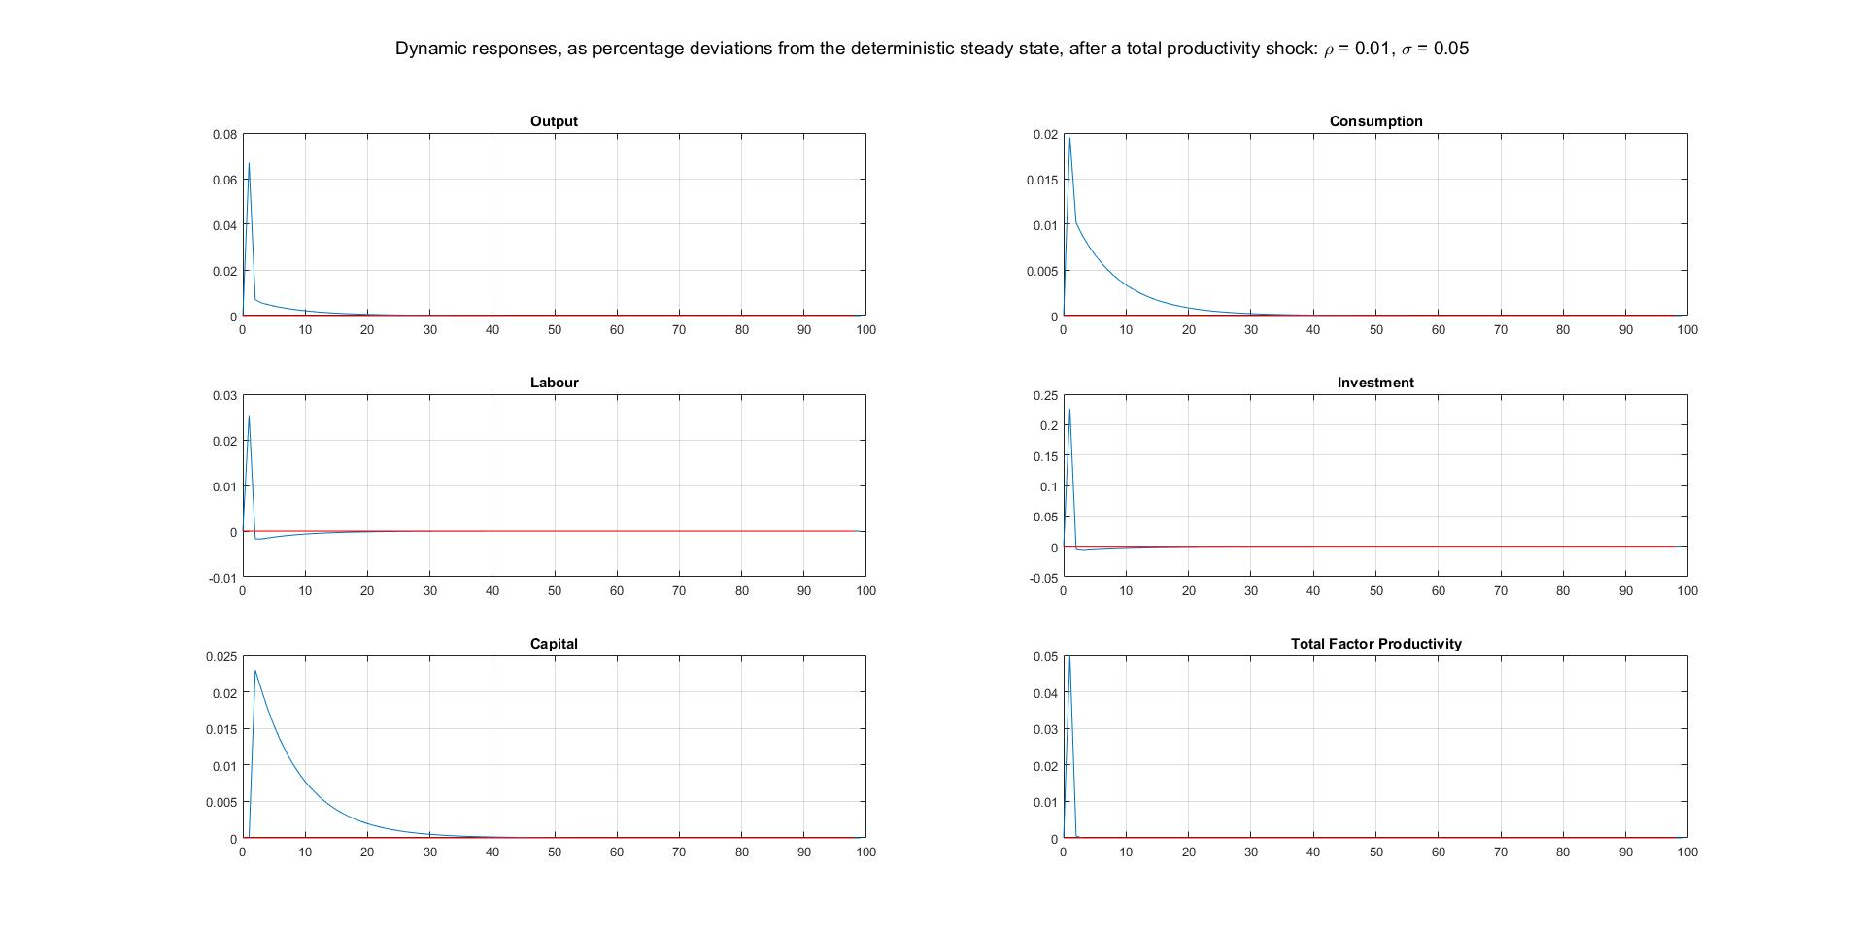

1. Explain the role of consumption smoothing in shaping up these responses.
2. Explain the role of the income and substitution effects of a change in the real wage rate in shaping up the response of the labor input