Chapter 20
Capital Adequacy

Multiple Choice Questions
74. | The difference between the market value of assets and liabilities is the definition of the  A. accounting value of capital.  B. regulatory value of capital.  C. economic value of capital.  D. book value of net worth.  E. adjusted book value of net worth.

75. | Regulatory-defined capital and required leverage ratios are based in whole or in part on  A. market value accounting concepts.  B. book value accounting concepts.  C. the net worth concept.  D. the economic meaning of capital.  E. None of the above.

77. | Under market value accounting methods, FIs  A. must write down the value of their assets to fully reflect market values.  B. have a great deal of discretion in timing the write downs of problem loans.  C. must conform to regulatory write-down schedules.  D. have an incentive to fully reflect problem assets as they become known.  E. are required to invest in expensive computerized bookkeeping systems.

81. | What is the impact on economic capital of a 25 basis point decrease in interest rates if the FI is holding a 20-year, fixed-rate, 11 percent annual coupon bond selling at a par value of $100,000?  A. A decrease of $250.  B. An increase of $250.  C. An increase of $2,024.  D. A decrease of $1,959.  E. No impact on capital since the book value is unchanged.  Fair market value of bond:  $102,023.82 - $100,000 ≈ +$2,024

82. | From a regulatory perspective, what is the impact on book value capital of a 25 basis point decrease in interest rates if the FI is holding a 20-year, fixed-rate, 11 percent annual coupon $100,000 par value bond?  A. A decrease of $250.  B. An increase of $250.  C. An increase of $2,023.  D. A decrease of $1,959.  E. No impact on capital since the book value is unchanged.

84. | Under historical accounting methods for the market value of capital, FIs  A. must write down the value of their assets to fully reflect market values.  B. have a great deal of discretion in timing the write downs of problem loans.  C. must conform to regulatory write-down schedules.  D. have an incentive to fully reflect problems in the asset portfolio as they become known.  E. invest in expensive computerized bookkeeping systems.

86. | Using a strict market value accounting might cause regulators to  A. revert to book value accounting in order to determine net worth.  B. close banks too early under prompt corrective action requirements.  C. exempt Dis from prompt corrective action.  D. allow banks to operate without oversight even with negative net worth.  E. suspend regulatory capital requirements during temporary spikes in interest rates.

88. | Which of the following is NOT a typical argument against market value accounting?  A. Market value accounting introduces an unnecessary degree of variability into an FI's earnings.  B. The use of market value accounting may reduce the willingness of FI's to invest in longer-term assets.  C. FI's are increasingly trading, selling, and securitizing assets.  D. Market value accounting is difficult to implement.  E. Market value accounting may interfere with an FI's special functions as lenders and monitors of credit.

89. | The U.S. banking industry built up record levels of capital in the early 2000s because  A. the economy went through a downturn.  B. problem loans increased.  C. the regulators required higher amounts of equity sales.  D. of record high levels of profitability.  E. of mergers between large banks.

90. | Bank regulators set minimum capital standards to  A. inhibit rapid growth rate of bank assets.  B. protect shareholders from managerial fraud or incompetence.  C. protect creditors from decreases in asset values.  D. force banks to follow socially desirable policies.  E. make work for regulators.

91. | The concept of prompt corrective action refers to the requirement  A. that bank managers must address problems in the loan portfolio when they are first identified.  B. that regulators must take specific actions when bank capital levels fall outside the well-capitalized category.  C. that a receiver must be appointed when a bank's book value of capital to assets falls below 2 percent.  D. that b and c above are correct.  E. that all of the above are correct.

93. | The Basel capital requirements are based upon the premise that  A. banks with riskier assets should have higher capital ratios.  B. banks with riskier assets should have lower capital ratios.  C. banks with riskier assets should have lower absolute amounts of capital.  D. banks with riskier assets should have higher absolute amounts of capital.  E. there is no relationship between asset risk and capital.

94. | The Basel I capital requirements as currently implemented include  A. different credit risks of on-balance-sheet assets.  B. different credit risks of off-balance-sheet assets.  C. the consideration of market risk in 1998.  D. All of the above.  E. Only two of the above.

95. | The Basel II Accord effective at year-end 2007 in the United States  A. includes provisions covering minimum capital requirements for credit, market, and interest rate risk.  B. stresses the regulatory supervisory process by requiring regulators to be more involved in evaluating the bank's specific risk profile and environment.  C. requires only banks on the regulatory problem bank list to disclose publicly the degree and depth of problem issues as well as their capital adequacy.  D. All of the above.  E. Answers B and C only.

96. | The measurement of credit risk under the Basel II Accord allows banks to choose between  A. a standardized approach similar to that used under Basel I.  B. a basic indicator approach that will cause banks to hold an additional 12 percent of capital.  C. an internal rating system in which they must adhere to strict methodological and disclosure standards.  D. All of the above.  E. Answers A and C only.

97. | The bank is considering changing its asset mix by moving $100 million of commercial loans into Treasury securities. If it does change the asset mix and capital remains the same, the risk-based capital ratio  A. will not change because the total assets have not changed.  B. will decrease because the earnings rate on Treasuries is less than on loans.  C. will increase by 16.67 percent.  D. will increase because the assets will have less risk.  E. will change, but the direction cannot be determined with the information given.

98. | Which of the following is not a category of capital under Basel III?  A. Tier III capital.  B. Tier II capital.  C. Common Equity Tier I.  D. Total risk-based capital.  E. Tier I capital.

100. | Which of the following is not included in the Common Equity Tier I capital under Basel III?  A. Retained earnings.  B. Par value of common shares issued by the bank.  C. Par value of noncumulative perpetual preferred stock.  D. Paid-in excess (surplus) of common stock.  E. Common shares issued by consolidated subsidiaries of the bank.

101. | Which of the following statements best describes the treatment of adjusting for credit risk of off-balance-sheet activities?  A. All OBS activities are treated equally in making credit-risk adjustments.  B. Standby letter of credit guarantees issued by banks to back commercial paper have a 50 percent conversion factor.  C. The credit or default risk of over-the-counter contracts is approximately zero.  D. The current exposure component of the credit equivalent amount of OBS derivative contracts reflects the credit risk if the contract counterparty defaults.  E. The treatment of interest rate forward, option, and swap contracts differs from the treatment of contingent or guarantee contracts.

102. | A criticism of the Basel I risk-based capital ratio is  A. the incorporation of off-balance-sheet risk exposures.  B. the application of a similar capital requirement across major banks in international banking centers across the world.  C. the more systematic accounting of credit risk differences.  D. the lack of appropriate consideration of the portfolio diversification effects of credit risk.  E. Answers B and C only.

103. | Which of the following is NOT a criticism of the Basel I risk-based capital ratio?  A. All commercial loans are given equal weight regardless of the credit risk of the borrower.  B. The ratio incorporates off-balance-sheet risk exposures.  C. Grouping assets into different risk categories may encourage balance sheet asset allocation games.  D. The treatment does not include interest rate or foreign exchange risk.  E. The weights in the four risk categories imply a cardinal measurement of relevant risk between each category.

104. | The primary difference between Basel I and the proposed Basel III in calculating risk-adjusted assets is  A. that Basel II considers OBS assets.  B. the use of only three weight classes rather than four classes.  C. a heavier reliance on the use of ratings by external credit rating agencies for the assignment of assets to weight classes.  D. All of the above.  E. Answers A and C only.

105. | The primary difference between Basel I and the proposed Basel III in converting OBS  values to on-balance-sheet credit equivalent amounts is  A. the use of credit ratings in Basel III to assign credit risk weights on the OBS activities.  B. the use of six weight classes by Basel III rather than four classes.  C. the use of the underlying counterparty activity in Basel II to assign credit risk weights on the OBS activities.  D. All of the above.  E. Answers A and C only.

107. | The potential exposure component of the credit equivalent amount of OBS derivative items reflects  A. the probability of an adverse price movement in contracts.  B. the cost of replacing a contract if a counterparty defaults today.  C. the probability today of a counterparty contract default in the future.  D. the maximum price loss for any given position.  E. Answers A and D only.

108. | The current exposure component of the credit equivalent amount of OBS derivative items reflects  A. the probability of an adverse price movement in contracts.  B. the cost of replacing a contract if a counterparty defaults today.  C. the probability today of a counterparty contract default in the future.  D. the maximum price loss for any given position.  E. future volatility of the underlying.

109. | The calculation of the risk-adjusted asset values of OBS market contracts  A. nearly always equals zero because the exchange over which the contract initially traded assumes all of the risk.  B. requires multiplication of the credit equivalent amounts by the appropriate risk weights.  C. requires the calculation of a conversion factor to create credit equivalent amounts.  D. All of the above.  E. Answers B and C only.

110. | The buffer proposed by Basel III that is designed to ensure that DIs build up a capital surplus outside of periods of financial distress is called the  A. Capital conservation buffer.  B. Countercyclical buffer.  C. Leverage buffer.  D. Tier II buffer.  E. CET1 capital buffer.

111. | The purpose of the countercyclical buffer proposed by Basel III is to  A. expose those banks with inadequate capital to survive economic downturns.  B. assist insolvent banks build capital during economic expansions.  C. protect the banking system and reduce systematic exposures to economic downturns.  D. enhance global movement of funds to those countries experiencing excess aggregate credit growth.  E. force DIs to immediately adjust capital to meet the 2.5 percent level of buffer capital required.

112. | Failure to meet the capital conservations buffer and the countercyclical buffer guidelines instituted under Basel III will result in limits to all of the following except  A. bonuses paid to executives of the institution.  B. regularly scheduled dividends paid to stockholders.  C. special dividends meant to distribute retained earnings to stockholders.  D. lending to international entities.  E. buyback programs of common stock.

114. | Under Basel III, Globally Systematically Important Banks (G-SIBs) were identified by the Bank for International Settlements (BIS) by all of the following indicators except:  A. Size.  B. Lack of substitutes for the institution's services.  C. Cross-jurisdictional activity.  D. Interconnectedness with other institutions.  E. Ability to obtain insurance or other guarantees on deposits.

116. | Calculation of the "add-on" to the risk-based capital ratio to measure operational risk  A. may be done using the Basic Indicator Approach.  B. may be done using the Standardized Approach.  C. may be done using the Advanced Measurement Approach.  D. All of the above.  E. Answers A and B only.

117. | Which approach used in calculating capital to cover operational risk allow banks to rely on internal data for the calculation of regulatory capital requirements?  A. Standardized approach.  B. Advanced measurement approach.  C. Basic indicator approach.  D. Internal ratings-based approach.  E. All of the above.

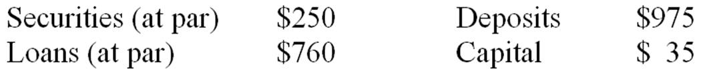

124. | How would regulators characterize this FI based on the Standardized Approach leverage ratio zones of Basel III?  A. Well capitalized.  B. Undercapitalized.  C. Severely undercapitalized.  D. Overcapitalized.  E. Insolvent.  LR = $35/(250 + 760) = 35/1,010 = 0.03465 ≈ 3.47 percent  Well-capitalized = 5 percent  Adequately-capitalized = 4 percent

125. | If problem loans reduce the market value of the loan portfolio by 25 percent, what is the value of regulatory defined (book value) capital?  A. $35 million.  B. -$155 million.  C. $7 million.  D. -$7 million.  E. $0.  Loan portfolio × reduction percentage = decrease in market value of loan portfolio  $760 × (-0.25) = -$190  The decrease in the market value of the loan portfolio has no effect on book value, so there is no change in the capital: $35

126. | If problem loans reduce the market value of the loan portfolio by 25 percent, what is the market value of capital?  A. $35 million.  B. -$155 million.  C. $7 million.  D. -$7 million.  E. $0.  Loan portfolio × reduction percentage = decrease in market value of loan portfolio  $760 × (-0.25) = -$190  Under market value accounting, the $35 million in capital will be reduced by $190 million.  MV capital = $35 - $190 = -$155

127. | Given that 25 percent of the loans have been identified as problem loans, and if historical cost accounting methods allow the bank to write down only 10 percent of the problem loans, what will be the book value of capital?  A. $35 million.  B. -$155 million.  C. $16 million.  D. -$7 million.  E. $0.  Loan portfolio × reduction percentage × write-down percentage = decrease in reported value of loan portfolio  $760 × (-0.25) × 0.10 = -$19  Under market value accounting, the $35 million in capital will be reduced by $19 million.  MV capital = $35 - $19 = -$16

128. | If the loan portfolio consists of a five-year, 10 percent annual coupon loan selling at par, what is the market, or economic, value of capital if interest rates increase 1 percent?  A. $35 million.  B. -$155 million.  C. $7 million.  D. -$7 million.  E. $0.  MV with rate increase  Change in market value of loans = $732 - $760 = -$28  Change in economic value of capital = $35 - $28 = $7 million

129. | If the loan portfolio consists of five-year, 10 percent annual coupon par value loans, what is the market, or economic, value of capital if interest rates decrease 2 percent?  A. $35 million.  B. $96 million.  C. $60 million.  D. -$7 million.  E. $0.  MV with rate decrease  Change in market value of loans = $820 - $760 = +$61  Change in economic value of capital = $35 + $61 = $96 million

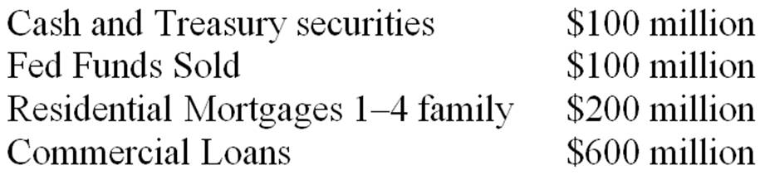
Note: The residential mortgages all have a loan-to-value of between 60 and 80 percent.

130. | If the bank has capital of $50 million, what is the leverage ratio using the standardized approach?  A. 5.00 percent.  B. 8.33 percent.  C. 25.0 percent.  D. 50.0 percent.  E. None of the above.  Total Assets = 100 + 100 + 200 + 600 = $1,000  Total Capital = $50  LR = 50/1,000 = 0.05 = 5.0 percent

131. | What is the amount of risk-adjusted assets?  A. $1,000 million.  B. $720 million.  C. $900 million.  D. $600 million.  E. $700 million.  Risk-Adjusted Assets =  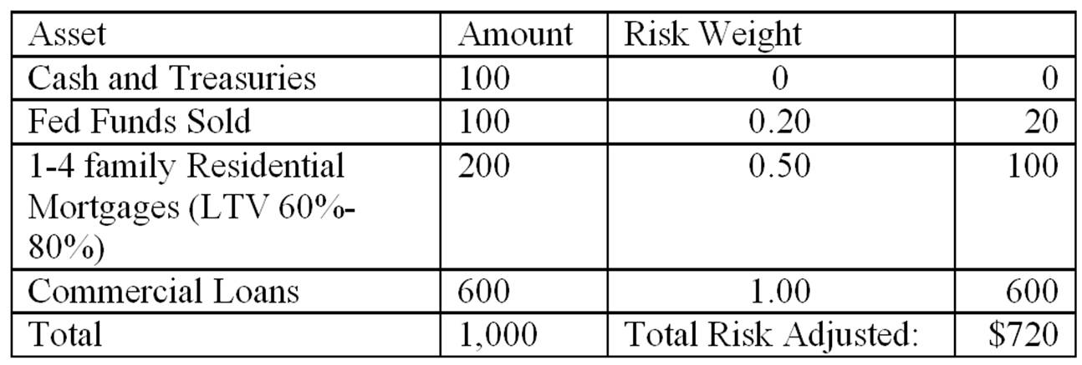

132. | What is the ratio of capital to risk-adjusted assets, if the bank has capital of $50 million?  A. 5.00 percent.  B. 5.56 percent.  C. 6.94 percent.  D. 8.33 percent.  E. 6.25 percent.  Capital to risk-adjusted assets: $50/$720 = 0.0694

Sigma Bank has the following balance sheet in millions of dollars. Unless mentioned otherwise, all assets are associated with corporate customers (not governments or sovereigns). Values are in millions of dollars. Refer to table 20-8 for appropriate risk weights.
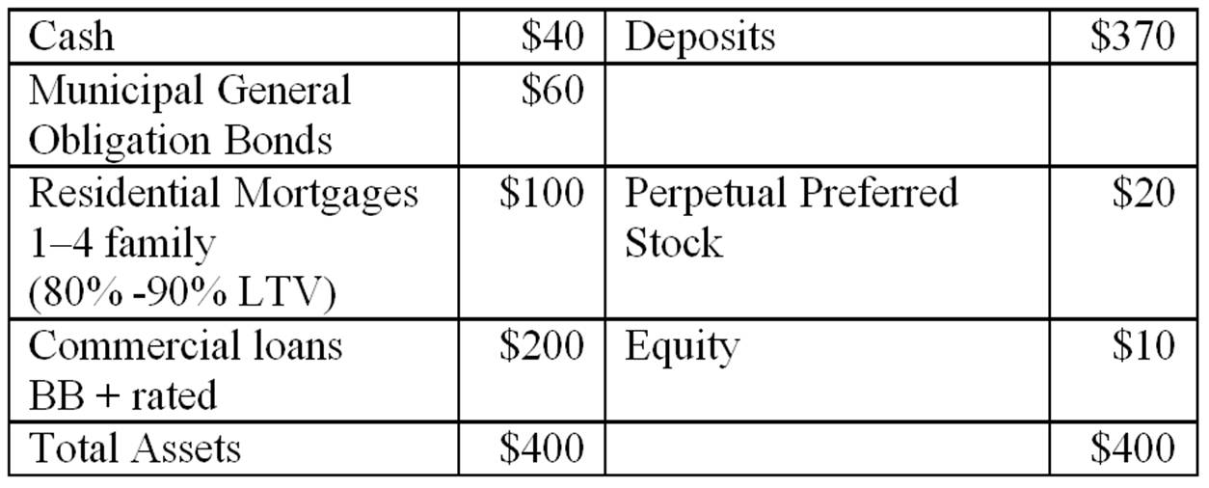
Off balance sheet contingent liabilities (Refer to Table 20-10)
$40 million direct-credit substitute standby letters of credit issued to a U.S. corporation.
$40 million commercial letters of credit issued to a corporation
Off-balance sheet derivatives (Refer to Table 20-11)
$200 million 10-year interest rate swaps
$100 million 2-year forward DM contracts

133. | What is Sigma Bank's risk-adjusted assets as defined by the Basel standards for its on-balance-sheet assets only?  A. $400 million.  B. $360 million.  C. $310 million.  D. $287 million.  E. $236 million.  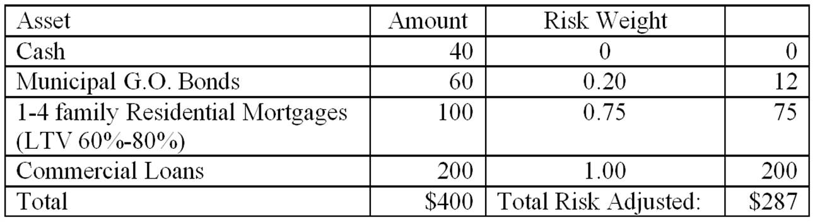

134. | What is the minimum required Tier I and Total risk-based capital for the on-balance-sheet assets in order for the DI to be adequately capitalized?  A. $8 million; $8 million.  B. $16.87 million; $16.87 million.  C. $17.22 million; $22.96 million.  D. $22.96 million; $28.70 million.  E. $10.8 million; $8 million.  In order to be adequately capitalized, Tier I capital must be 6.0 percent and Total Risk-based capital is to be 8.0 percent.  Recall that total risk based capital will include the preferred stock as Tier II capital.  Tier I capital = $287 million × 0.06 = $17.22 million.  Total Risk Based Capital = $287 × 0.08 = $22.96 million.  Tier 1 capital includes only equity: $10 million.  Total risk-based capital is equity + perpetual preferred: $10 + $20 = $30 million.

135. | Is the bank adequately capitalized for its on-balance-sheet assets based on the Basel standards?  A. Yes, because both Tier I and Tier II capital each exceed the required minimum.  B. Yes, because both the Tier I and Tier II combined exceeds the required minimum.  C. No, because both Tier I and Tier II capital each are below the required minimum.  D. No, because Tier I is below the required minimum while Tier II exceeds the required minimum.  E. No, because Tier I is above the required minimum while Tier II is below the required minimum.  Tier 1 capital includes only equity: $10 million.  Amount of Tier I capital required to be adequately capitalized: $17.22.  Total risk-based capital includes equity and perpetual preferred: $10 + $20 = $30 million.  Amount of total risk-based capital required to be adequately capitalized: $22.96 million.

136. | What is the credit equivalent amount of the off-balance-sheet letters of credit, both standby and commercial?  A. $9.6 million.  B. $16.0 million.  C. $48 million.  D. $72 million.  E. $80 million.  Refer to Table 20-10  Direct-credit substitute standby letters of credit conversion factor = 100 percent  Commercial letters of credit conversion factor = 20 percent  Risk weights of each is 100%  Credit equivalent amount = (Face Value OBS item × conversion factor)  CEA = ($40 standby letter × 1.00) + ($40 commercial letter × 0.20)  CEA= $40 + $8 = $48 million

137. | What is the minimum total risk-adjusted capital (Tier I + Tier II) required for both of the off-balance-sheet letters of credit under the Basel II standards?  A. $3.84 million.  B. $3.68 million.  C. $3.20 million.  D. $4.80 million.  E. $6.40 million.  On-BS asset value of Off-BS item = (Credit equivalent amount × risk weight)  On-BS asset value of Off-BS item = [(FV of OBS item × CF) × RW]  On-BS asset value = [($40 × 1.00) × 1.00] + [$40 × 0.20) + 1.00] = $48 million  In order to be adequately capitalized, total risk-based capital must be at least 8.0 percent.  CEA of OBS = $48 × 0.08 = $3.84 million

138. | What is the credit equivalent amount of the off-balance-sheet interest rate swaps if it is in-the-money by $1 million?  A. $1.0 million.  B. $2.0 million.  C. $3.0 million.  D. $4.0 million.  E. $5.0 million.  Refer to Table 20-11  10-year interest rate swap credit conversion factor = 1.5 percent  Credit equivalent amount = (Notational value × Potential exposure conversion factor) + replacement cost if greater than zero.  CEA= ($200 × 0.015) + $1 = $3 million + $1 million = $4 million

139. | What is the credit equivalent amount of the off-balance-sheet foreign exchange contracts if it is out-of-the-money by $4 million?  A. $1.0 million.  B. $2.0 million.  C. $5.0 million.  D. $6.0 million.  E. $9.0 million.  Refer to Table 20-11  One to 5 year foreign exchange rate contract credit conversion factor = 5.0 percent  Credit equivalent amount = (Notational value × Potential exposure conversion factor) + replacement cost if greater than zero.  CEA= ($100 × 0.05) + $0 = $5 million + $0 = $5 million

140. | What is the minimum total capital (Tier I + Tier II) required to be adequately capitalized for the off-balance sheet derivative contracts (both interest rate swaps and foreign exchange forwards) under Basel II?  A. $0.24 million.  B. $0.36 million.  C. $0.72 million.  D. $0.60 million.  E. $0.48 million.  Both interest rate and FX contracts carry a risk weight of 100%  Total capital needed = [(CEA of swap × RW) + (CEA of FX × RW)] × 0.08  Total capital needed = [($4 million + $5 million) × 0.08] = $0.72 million

Fifth Bank has the following balance sheet with values stated in millions of dollars. All assets are associated with corporate customers (not governments or sovereigns). Refer to Table 20-8 for associated risk weights.
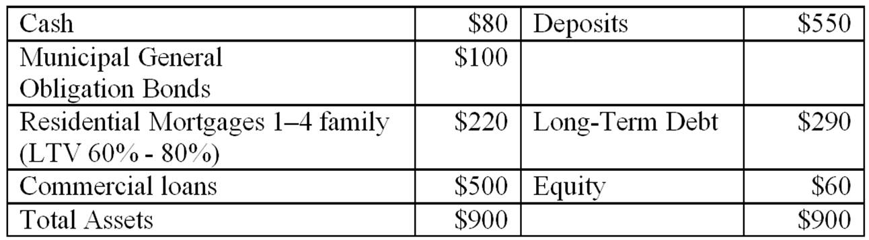
In addition, Fifth Bank has off-balance sheet items as follows: (Refer to Tables 20-10 and 20-11)
$50 million in commercial letters of credit (LCs),
$300 million in 3-year interest rate swaps that are in-the-money by $2 million
$50 million in 4-year forward FX contracts that are out-of-the money by $2 million

141. | What is the amount of risk adjusted on-balance-sheet assets of the bank as defined under the Basel II standards?  A. $130.0 million.  B. $685.0 million.  C. $720.0 million.  D. $630.0 million.  E. $900.0 million.  Risk-Adjusted Assets =  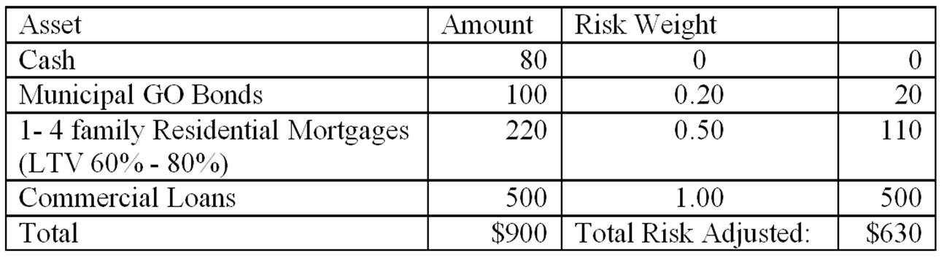

142. | Is Fifth Bank currently over or under capitalized for on-balance-sheet assets in order to be considered well capitalized according to Basel III?  A. Overcapitalized for both Tier I and Total capital standards.  B. Overcapitalized for Tier I standard; Undercapitalized for Total standard.  C. Undercapitalized for Tier I standard; Overcapitalized for Total standard.  D. Undercapitalized for both Tier I and Total capital standards.  E. Unable to determine.  In order to be well capitalized, Tier I capital must be 8.0 percent and Total Risk-based capital must be 10.0 percent.  Tier I capital required = $630 million × 0.08 = $50.40 million  Total risk-based capital required = $630 × 0.10 = $63.00 million  For Tier I standard, Fifth Bank is ($60 - $50.40) = $9.6 million OVER the minimum capital required.  For Total risk-based capital standard, Fifth Bank is ($60 - $63.0) = $3.0 million UNDER the minimum capital

143. | What are, respectively, the credit equivalent value of the letters of credit, interest rate swaps, and FX contracts?  A. $10.0 million; $3.5 million; $5.0 million.  B. $50.0 million; $300 million; $50.0 million.  C. $5.0 million; $1.5 million; $5.0 million.  D. $10.0 million; $1.5 million; $5.0 million.  E. $5.0 million; $3.5 million; $5.0 million.  Letter of Credit  Refer to Table 20-10  Commercial letters of credit conversion factor = 20 percent  Credit equivalent amount = (Face Value OBS item × conversion factor)  CEA_{lc}= $50 × 0.20 = $10 million  Interest rate swap  Refer to Table 20-11  3-year interest rate swap credit conversion factor = 0.5 percent  Credit equivalent amount = (Notational value × Potential exposure conversion factor) + replacement cost if greater than zero.  CEA_{swap}= ($300 × 0.005) + $2 = $1.5 million + $2 million = $3.5 million  FX forward contract  Refer to Table 20-11  One to 5 year foreign exchange rate contract credit conversion factor = 5.0 percent  Credit equivalent amount = (Notational value × Potential exposure conversion factor) + replacement cost if greater than zero.  CEA_{FX}= ($100 × 0.05) + $0 = $5 million + $0 = $5 million

144. | What are the total risk-adjusted off-balance-sheet assets of the bank as defined under the Basel II standards?  A. $400 million.  B. $16.5 million.  C. $11.5 million.  D. $13.5 million.  E. $18.5 million.  All of these OBS items carry a risk weight of 100%  Total on-balance sheet asset value equivalents = [(CEAl_{c} × RW_{lc}) + (CEA_{swap} × RW_{swap}) + (CEA_{FX} × RW_{FX}]  Total on-balance sheet asset value equivalents = [(10 × 1.00) + (3.5 × 1.00) + (5 × 1.00)] = $18.5 million

145. | What is the minimum Tier 1 and Total risk-based capital Fifth Bank needs in order to be considered adequately capitalized under Basel III capital requirements for both on-balance sheet and off-balance sheet items?  A. $40.71 million; $63.0 million.  B. $38.91 million; $51.88 million.  C. $51.88 million; $64.85 million.  D. $50.40 million; $67.5 million.  E. $38.91 million; $50.40 million.  Total Risk-Adjusted Assets = Risk-Adjusted On- and Off-Balance sheet assets  Total = 630 + 18.5 = $648.5 million.  In order to be adequately capitalized, Tier I capital must be 6.0 percent and Total Risk-based capital must be 8.0 percent.  Tier I capital required = $648.5 million × 0.06 = $38.91 million  Total risk-based capital required = $648.5 × 0.08 = $51.88 million

