Does Corporate Governance Matter? Why the Corporate Performance of Toyota and Canon is Superior to GM and Xerox
Masaru Yoshimori*
CORPORATE GOVERNANCE, Vol. 13, No. 3, May 2005

Long term performance of Toyota versus GM and Canon versus Xerox 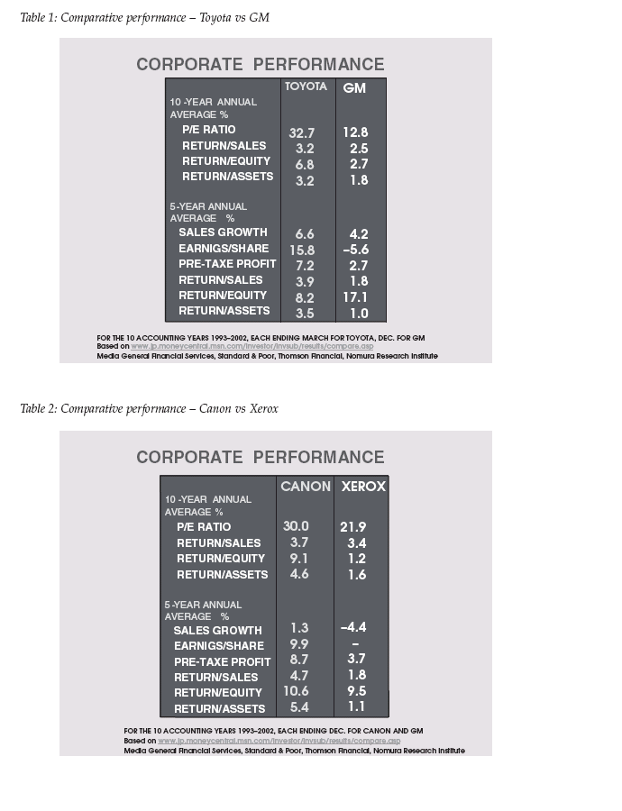

Α Japan–US comparison of corporate governance

The key stakeholder at Toyota and GM
Toyota is without doubt one of the most traditional Japanese firms in that it prioritises job security. The key stakeholder at Toyota is therefore its people. This stance dates back to 1949 and the early 1950s, when the firm was at the brink of bankruptcy and had to dismiss employees. Toyota survived thanks to the injection of credit by the banking consortium backed up by the Bank of Japan. Over half a century later, Toyota has never been in deficit nor axed employees for restructuring purposes.
Board Chairman Okuda describes this principle as “market economy with a human face”. Even during the 1990s, Toyota doggedly defended its position against those in Japan and elsewhere who clamoured for restructuring in favour of shareholder value. Okuda (2002) sharply criticised some of the Japanese CEOs for shedding employees, which he dismissed as “a short-sighted view dominated by stock market logic”.
In 1998, Moody’s Investors Services downgraded the Toyota’s bond rating by one notch because of its lifetime employment which does not enable Toyota to deal effectively with significant changes in the business environment”. Okuda (1999) said he could not understand why lifetime employment justified the negative rating when even excellent US firms such as Hewlett Packard and Boeing were doing the same. He takes a relativist stance in arguing that the American system is relevant only in the American socio-economic environment, and should not be applied elsewhere as a universal standard.
According to Okuda, Toyota’s corporate culture is founded on “the simple belief that people are at the centre of all economic activities”. He stresses that lifetime employment enables the firm to accumulate employee skills and strengthens their identification with the destiny of their company. He emphasises that “management with a long-term horizon is good for the shareholders, and that respect for human resources has by far higher universal validity than the market principle that has been popular only in recent years”. Okuda(2002) concludes by affirming that management that balances the interests of three stakeholders, i.e. shareholders, management and employees, will have staying power.
GM, on the other hand, epitomises the US mainstream ideology of shareholder primacy. Legendary GM Chairman Alfred P. Sloan once wrote:
The measure of a business enterprise as a business is . . . not merely growth in sales or assets but return on the shareholders’ investment, since it is their capital that is being risked, it is in their interests first of all that the corporation is supposed to be run in the private-enterprise scheme of things. (1964)
GM took shareholder interests seriously early on. Sloan and Pierre Dupont were major shareholders of GM and took an interest in share prices. In 1923, Dupont was instrumental in implementing one of the first stock option plans in the United States. He sold 30 per cent of his GM shares to the Managers Securities Company, which was created to manage the executive stock option plan. One of the reasons for Dupont’s move was to “create a partnership relationship” with management. Dupont was convinced that this incentive scheme for the executives would increase dividends and the stock price of GM, resulting in increased value for Dupont’s remaining stake (Sloan, 1964).
Shareholder primacy was reemphasised in 1993 by Chairman Smale in his letter to shareholders. “Your Board of Directors”, he wrote, “is responsible to you, the shareholders”. Today the mission of the GM Board of Directors is to represent “the owners’ interest in perpetuating a successful business”. The Board is also to be responsible to “GM’s customers, employees, suppliers and to the communities where it operates – all of whom are essential to a successful business”. But this statement makes clear that non-shareholder interests are considered as a means of serving the interests of the shareholders.

The key stakeholder at Canon and Xerox
Canon shares the same concept of the corporation as Toyota. Indeed, Canon has never laid off employees in its entire history. Since 1950, Canon introduced the Tripartite Profit Sharing System, whereby one-third of profits go to labour, one-third to the shareholders and the balance to the management. The system is largely in place today. CEO Mitarai (2002) believes that a firm is only as good as its employees, hence he puts them before the shareholders. Mitarai says that lifetime employment offers higher returns on investment in employee education and training, in house accumulation of employee and management expertise, and trust and solidarity among people through long-term working relationships and a common destiny. Such a working environment, in Mitarai’s view, fosters self-discipline and a sense of mission to improve corporate performance – thus being the basis of good corporate governance in the Japanese socio-cultural context.
The pitfall of lifetime employment is, for Mitarai, the remuneration and promotion based solely on seniority, because it does not take into account individual differences in job performance. This will result in dulled work incentives of high achievers, lead to cosy relations among employees and may thus even nduce unethical and illegal behaviour. Canon’s remedy is meritocracy in human resources management, which Mitarai defines as offering equal opportunities to every employee regardless of gender, educational background and job category. As proof of the effectiveness of their efforts to foster talent, Mitarai points out that Canon is second to IBM in terms of the cumulative number of patents granted in the United States in the past 10 years, which generated a record royalty income of ¥2.4 billion or US$20 million in 2001.
The key stakeholder for Xerox is shareholders, as in the case of GM. The firm’s Corporate Governance Guidelines stipulate that the Board is to represent the interests of the shareholders. The company experienced a serious downturn in 2000 and 2001, and had to resort to severe job cuts. In January 2001, the company announced it was slashing 5,200 jobs, or 5 per cent of the workforce, followed by another cut of 2,000 jobs worldwide in the third quarter, followed by still another of 4,000 in the fourth quarter.

Conclusion
The foregoing comparison, albeit limited to two pairs of firms, seems to indicate that corporate governance plays a relatively limited role in long-term corporate performance. Other factors, namely corporate mission, ethics, culture and strategy, strike one as equally or perhaps more important factors for success. “External governance” may be defined as governance based on the presence of the majority of outside directors on the board, small board size, discipline by the stock market, shareholder activism by institutional and private shareholders, monitoring by audit firms, rating agencies, laws and rules, and sanctions against fraudulent conduct. Meanwhile the Toyota and Canon cases suggest that “internal governance” may also be built around corporate values, corporate culture, ethics and strategy.
The mainstream argument in agency theory puts a premium on the monitoring function and effectiveness of external governance to prevent the opportunistic behaviour of management. The relationship between external governance and corporate performance is only recently beginning to be examined. According to a US study by Dalton et al. (1998), no statistically significant relationship has been found between board independence and corporate performance. Separation of the board chairmanship and the CEO position is not associated with better corporate results, nor is board independence, however it may be defined. In fact, a larger, not smaller, board size is conducive to better performance (Dalton and Daily, 2000).
A crucial aspect of external governance is the independence of outside directors. But independence is extremely difficult to define. Formal and verifiable requirements such as working or business relationships with the company they serve, for instance, do not guarantee true independence of outside directors in their relationship with the CEO. Such relationships are more psychological. Outside directors are only as good as the CEO whom they are supposed to monitor and advise. Through various means such as high director remuneration or lucrative consulting and other pecuniary compensation, a selfinterested CEO can undermine their independence with relative ease, as the Enron case illustrates. The fact that whistle blowing by an insider divulged the wrongdoing at Enron and WorldCom is indicative of the failure of outside directors.
Toyota and Canon seem to allocate much more time and resources to indoctrination of their corporate culture, as well as formulation and implementation of viable strategies, than to corporate governance. In both firms, the Usstyle corporate governance system is practically non-existent. There is nothing special about their values and priorities, which are not particularly original. Most of them are not even formalised, but rather strongly internalized and practiced daily by people in all echelons.
We have been preoccupied over the last decade with the external governance system focused on outside directors. It may be high time that we looked more closely at internal governance mechanisms, instead of trying to refine the external governance system, which is becoming increasingly complex and onerous while its contribution to corporate performance is not conclusively proven. This statement is not intended to dismiss external governance but stress more reliance on internal governance.

Questions
- What is the major differences between the CG systems of USA and Japan?
- Are USA manages less sensitive to other stakeholders?
- Does CG as an “external system of control” really adds more value?
- Can an internal focus on values, culture and strategy make the external controls of CG redundant?
- Should all countries /corporations converge to a USA style of CG? Should there be universal standards?

